**Docker Task -3**

**Task Description:**

Create a custom docker image for nginx and deploy it using docker compose, where the volume bind mount should be at /var/opt/nginx location. Push the created custom docker image to your docker-hub.

Step 1:-

* Create directory using nano command

**mkdir nginx-docker**

* Navigate to the directory using the command below

**Cd mkdir nginx-docker**

* Creating dockerfile to create nginx image using the below command

**Nano dockerfile**

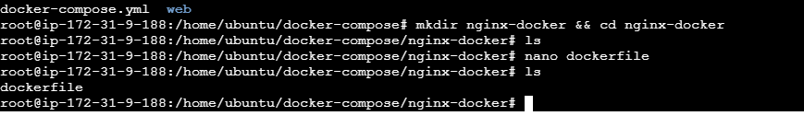

* Creating yml file using nano command and specifying the volume bind mount location as var/opt/nginx location

**Nano docker-compose1.yml**

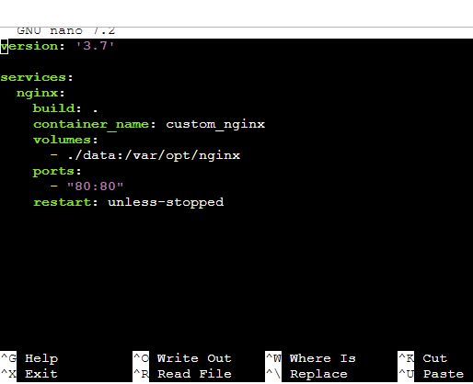

* Run the below command to build image from the yml file

**docker-compose build**

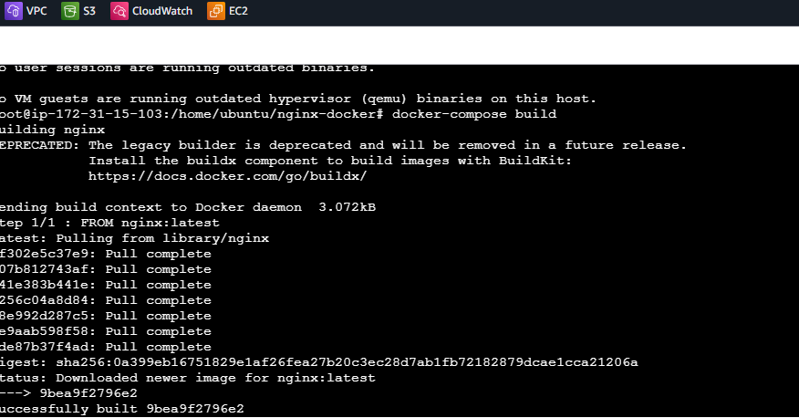

* Run the below command to list the images created

**docker images**

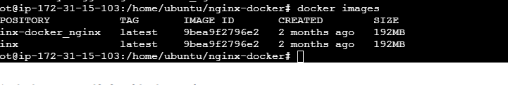

* After creating the image need to run the container using the below command

docker –compose up –d

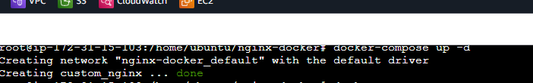

* Run the below command to list the container created

**Docker ps**

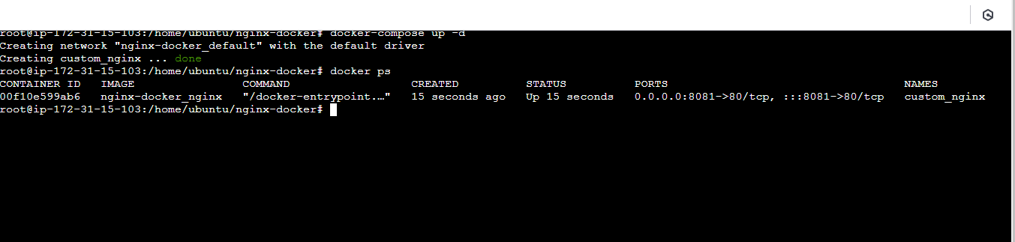

* Login to docker hub using the command

**login**

* Enter the credentials of docker hub

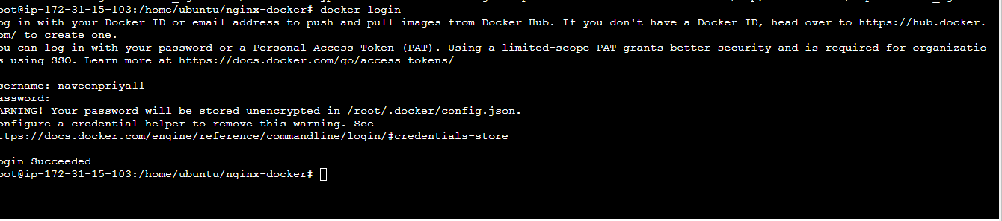

* Tag the image which needs to be pushed to the docker hub using the belo command

**docker tag nginx:latest naveenpriya11/nginx:V01**

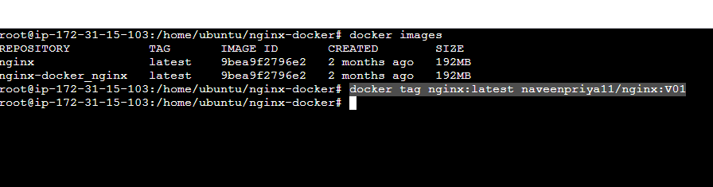

* Run the below command to list the images below screenshot shows the image is tagged

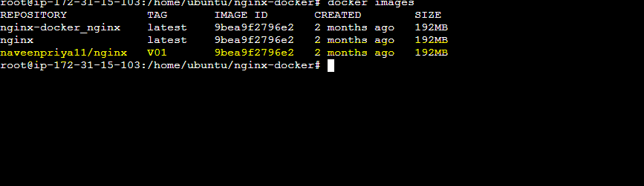

* Run the below command to push the tagged image to docker hub

**docker push naveenpriya11/nginx:V01**

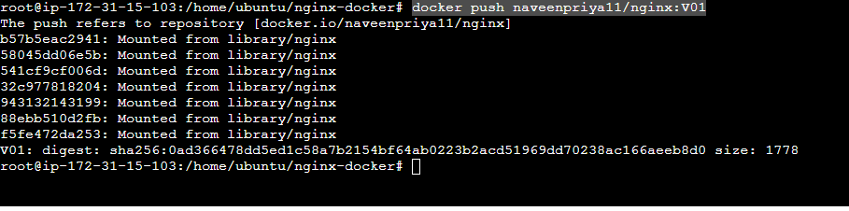

* Login to docker hub and navigate to the repository to view the image that is pushed

